Personal, Social and Emotional Development
Show confidence in linking up with others for support and guidance
Show increasing independence when selecting and carrying out activities
Show increasing confidence in new situations
Learn social skills and enjoy being with and talking to other children
Show awareness that some actions can hurt or harm others
Seek to do things for themselves, knowing that an adult is close by, ready to support and help if needed

Understanding the World
Explore, play and seek meaning in their experiences

Show an interest in why things happen
Are curious and interested in making things happen.

Investigate various construction materials

Show an interest in ICT

Recognise some special times in their lives and the lives of others

Anticipate some time based events such as mealtimes or home time

Communication and Language Development
Language for Communication
Learn new words rapidly and are able to use them in communicating about matters that interest them
Listen to stories with increasing attention and recall

Literacy
Linking Sounds and Letters
Show interest in play with sounds, songs and rhymes Distinguish one sound from another

Reading
Have some favourite stories, rhymes, songs, poems or jingles

Writing/Handwriting
Distinguish between the different marks that they have made
Sometimes give meaning to marks as they draw and paint

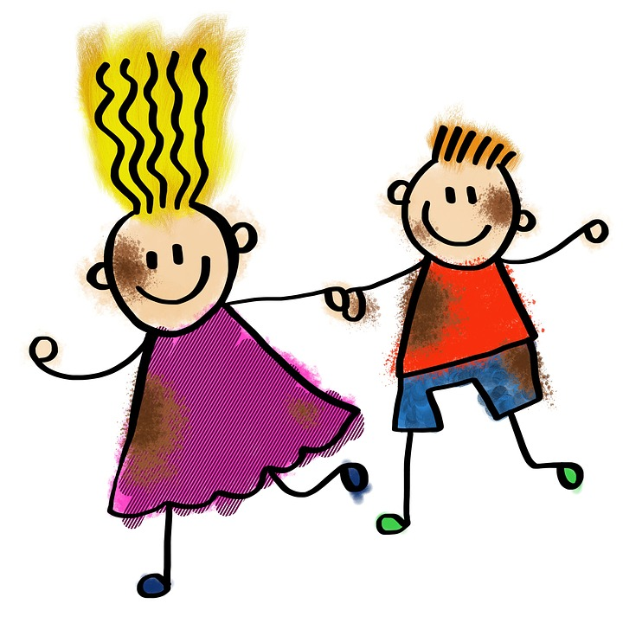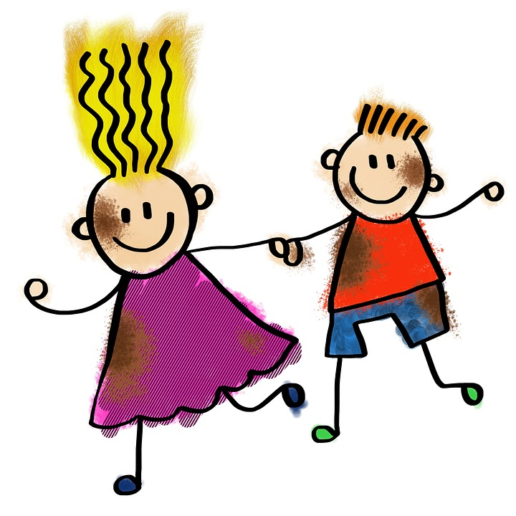

Autumn 1 – Nursery
Skills
Marvellous Me

Physical Development
Movement
Respond to rhythm, music and story by means of gesture and movement
Move spontaneously within available space
Gain control of their bodies and are becoming aware of how to negotiate the space and objects around them

Health and bodily awareness
Show emerging autonomy in self-care

Using equipment, tools and materials
Use increasing control in holding books, beaters and mark making tools
Engage in activities requiring hand eye coordination
Mathematics
Numbers as Labels and for Counting
Create and experiment with symbols and marks
Use some number language
Recite number names in sequence

Calculating
Categorise objects according to their properties
Begin to make comparisons between quantities

Shape, Space and Measures
Notice simple shapes and patterns in pictures
Begin to understand variations in size
Begin to categorise objects according to properties such as shape or size

Expressive Arts and Design
Begin to use representation as a form of communication

Begin to combine movement, materials, media or marks

Create sounds by banging, shaking, tapping or blowing

Join in favourite songs

Show an interest in the way a musical instrument sounds

Begin to make believe by pretending

