Personal, Social and Emotional Development
Playing in a group, extending and elaborating play ideas.
Initiating play, offering cues to peers to join them.
Sustaining play by responding to what others are saying or doing.
Being friendly by initiating conversations and forming good relationships with peers and familiar adults.

Understanding the World
Showing interest in the lives of people who are familiar to them.
Remembering and talking about significant events in their own experience.
Recognising and describing special times or events for family or friends.
Learning about our school and the people within it.
Being able to talk about themselves and their strengths.
Language for Communication
Developing listening and attention skills.

Writing
Giving meaning to marks.
Hearing, saying and using the initial sound in words (covering s,a,t,p,i,n,m,d,g,o,c,k,ck,e,u,r)
Writing own name.

Reading
Developing rhyming skills.
Increased awareness of story structure.
Suggesting how the story might end.
Showing interest in illustrations and print.
Handling books carefully.

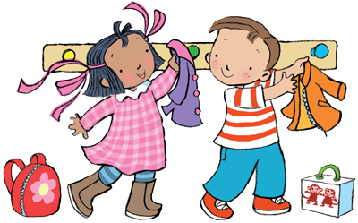

Malden Parochial School

Autumn 1 – Reception
Skills


Mathematics
Numbers
Recognising, reciting and counting numbers to 10.
Beginning to represent numbers.
Exploring the concept of number.
Investigating number problems.

Shape, Space and Measures
Exploring 2D shapes
Using positional language.
Shows interest in shapes in the environment.
Beginning to talk about the shapes of everyday objects
Expressive Arts and Design
Using movement to express feelings and respond to music.
Exploring rhythm.
Developing imaginative role-play.
Creating stories using toys.
Capturing experiences and responses with a range of media, such as music, dance and paint and other materials or words.
Physical Development
Movement
Moving skilfully and confidently in a range of ways.
Negotiating space successfully, adjusting speed or direction to avoid obstacles.
Catching a large ball.

Using equipment, tools and Materials
Drawing lines and circles using gross motor movements.
Using one-handed tools and equipment.
Holding a pencil between thumb and two fingers with control.

